CS 255 System Design Document Template

UML Diagrams

UML Use Case Diagram
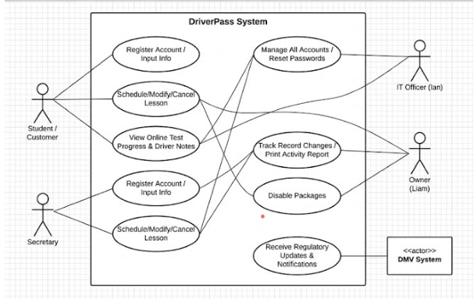S

UML Activity Diagrams
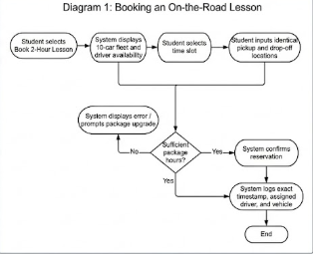
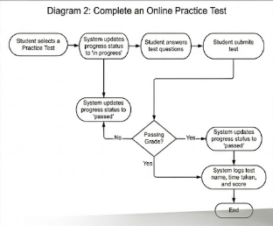

UML Sequence Diagram
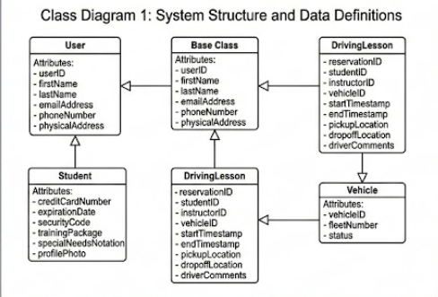

UML Class Diagram
classDiagram
class User {
+String userID
+String firstName
+String lastName
+String emailAddress
+String phoneNumber
+String physicalAddress
}

class Student {
+String creditCardNumber
+String expirationDate
+String securityCode
+String trainingPackage
+String specialNeedsNotation
+Image profilePhoto
}

class Instructor {
+String employeeID
+String licenseNumber
}

class DrivingLesson {
+String reservationID
+String studentID
+String instructorID
+String vehicleID
+DateTime startTimestamp
+DateTime endTimestamp
+String pickupLocation
+String dropoffLocation
+String driverComments
}

class PracticeTest {
+String testName
+Int timeTaken
+Float score
+String progressStatus
}

class Vehicle {
+String vehicleID
+Int fleetNumber
+String status
}

User <|-- Student
User <|-- Instructor
Student "1" -- "*" DrivingLesson : books
Instructor "1" -- "*" DrivingLesson : teaches
Vehicle "1" -- "*" DrivingLesson : used in
Student "1" -- "*" PracticeTest : takes.

Technical Requirements
Hardware Requirements
- The system must run entirely off the web, preferably deployed over a cloud environment.
- End-users will interact with the system via standard web browsers across internet-connected desktop computers and mobile devices.
Software & Database Requirements
- The database layer must securely process and isolate sensitive user registration details, including credit card numbers, addresses, and full names.
- The system requires a data handling architecture capable of generating downloadable report files that are compatible with local spreadsheeting software, such as Microsoft Excel.
- The online testing progress module must accurately calculate and maintain a four-state progress status variable for student exams.
Integration & Tool Requirements
- The system must include a DMV Integration Module to automatically receive notifications regarding rules, policies, and sample questions.
- This integration requires a standardized, compatible API or external web hook connection to push these updates directly to the platform.
Infrastructure & Security Requirements
- The cloud environment must natively handle automated background backups and systemic security protocols to minimize technical overhead.
- System data must only be modified or updated while online to ensure sync-accuracy across the cloud infrastructure and actively prevent data redundancy.
- The system must generate immutable activity reports to track operational modifications and maintain accountability.

